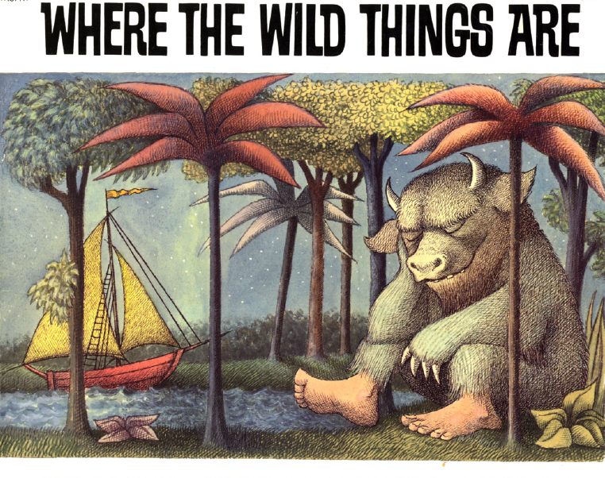AN INTEGRATED UNIT FOR FIRST GRADERS BY BRIAN LYKE
University of Alaska Southeast March 27, 2014

Student Author: Brian Lyke | Professor: Dr. Anne Jones
Course: ED621 Curriculum Development B | Grade Level: 1st | # of Students: 20
Date: March 27, 2014 | Length of Lesson: 5 days. 60 minute sessions.
Topic of Lesson:  People, Places and the Environment | Content Area: Social Studies, Science, Math, Literacy, Technology, Art and Drama
Materials: PDF version of Where the Wild Things Are by Maurice Sendak. A projector to display the story on the screen. Animal-Combining app and three computers. Animal Parts worksheet. Judgments worksheet. Colored pencils and drawing paper. Paint and mural paper. One King of all Wild Things crown and 20x clip-on tails/cat ears.

ALASKA STANDARDS ADDRESSED
Geography .B .4 | Students discuss how and why people identify with places;
Government .A .2 | Students discuss ideas like authority, power, freedom, and responsibility;
Science .C .2 .2 | Students can sort animals into groups based on appearance and behaviors;
MATH .CC .5 | Students can use the greater-than, less-than or equal-to symbols when comparing two numbers or groups;
Reading .IK .7 | Students can use illustrations in a story to describe its characters, events, setting, or problem-solution;
Technology .D | Students can use technology to share their ideas;
ART .C .5 | Students will be still and listen quietly as an audience member;
DRAMA .A .5 | Students work together to create and perform a dance;

OBJECTIVES  - I will create an illustration of a place that I identify with.  - I will use illustrations to describe and sort animals.  - I will compare different groups and objects using greater-than or less-than symbols.  - I will use technology to design and share my creation.  - I will define and discuss ideas like authority, power, freedom, and responsibility.  - I will work with a team to create and perform a dance, and then watch as other teams perform their dances.  SUMMATIVE ASSESSMENT  The students will collaborate in groups to create a large mural of an imaginary place. They will decorate the mural with custom-created wild things printed from a computer app. This will becomes set dressing for a brief, choreographed “Wild Rumpus” animal dance the group will perform for their peers.  Students will turn in two worksheets that show their effort in the Sort+Create and Be The Monarch center. | UNIT PRE-ASSESSMENT  The student will draw an imaginary wild place.  FORMATIVE ASSESSMENTS  - The student can draw scenery with detail.  - The student can explain the difference between imaginary and real.  - The student can use mathematical symbols to represent greater-than or less-than.  - The students can recognize numbers as being larger or smaller than each other.  - The student can define authority, power, freedom, and responsibility.  - The student can use animal-combining app.  - The student can recognize body parts as belonging to a particular animal.  - The student can learn and perform an eight-part dance with repeating movement.  UNIT POST-ASSESSMENT  The student will remember and draw a real wild landscape and write about their responsibility toward that place.

HOOK/  INTRO | The teacher asks her students to close their eyes and imagine a wild place.  She slowly asks questions to help the students refine their imagination:  - “IMAGINE A WILD PLACE where you feel safe & relaxed. Look around.”  “Are you sitting on dirt, sand, rock, moss or the branches of a tree?”  “Are you surrounded by colorful animals, tall trees, ice, or clouds?”  “What does this place smell like?”  “When would you choose to go to this place?”
Dates:  LABELS | Processes | Differentiation/Accommodations/  Modifications/Notes | Assessments, Products  - Formative Assessments
Day 1:  HOOK  READ  EXPLAIN  centers  DANCE | Ask the students to draw the wild place they imagined with detail. Encourage students to add details and color.  Read the first couple pages of the story “Where the Wild Things Are”  Split the class into four groups. Explain each center. These teams will rotate between activity centers throughout the week.  Introduce choreography for the Wild Rumpus dance and practice. | Split up the drawing time into tasks for inexperienced artists.  - Sketch it.  - Add details, or animals.  - Ink it.  - Color it.  Pre-teach vocab to ELL students.  Project the story onto the smart board for visual learners.  Consider arranging groups so each team has a diversity of strengths represented. (i.e. Naturalistic, Literacy, Sensory-Motor, Imaginative, Leadership) | Pre-Assessment:  Draw an imaginary wild place.  - The student can draw scenery with detail.  - The student can explain the difference between imaginary and real.
Day 2-4:  READ  CENTERS  DANCE | With each new day, the teacher reads a little more of the “Wild Things” story.  Then, teams work primarily in one center. Rotate each day.  At the end of the hour, all teams will take 10 minutes to practice their dance. | Allow students with shorter attention spans to switch centers when they grow bored. Students may re-do activities in different groups for Sort+Create or Be The Monarch. They may spend the whole hour painting their mural.  To meet all objectives, each student should at least try each activity once. | - See following page for more assessment and product information about centers.
Day 5:  OUTRO/  CLOSURE | Set up the classroom so teams can perform their “Wild Rumpus” dance. Students will watch as other teams perform their dances. All students participate in one final big group number led by the teacher.  Finally, the teacher will ask her students to imagine a real place in their life to draw. Then she asks students to write how they are the Kings and Queens of those wild places. |  | Summative Assessment:  Dance Performance  Post Assessment:  Draw a wild place. Write about your responsibility to it.

WILD THINGS CENTERS EXPLAINED
LABELS | Processes | Differentiation/Accommodations/  Modifications/Notes | Products  - Formative Assessments
1stCENTER  MAKE A  MURAL | Teams must create a large mural sketch of their own favorite imaginary world. Students can use projections for initial sketch. Students can color with paint/markers.  This will become a set dressing for the Wild Rumpus dance later. | Students can participate to their fullest ability in each center. If unable to dance or draw, students can contribute extra work to the other centers. | Product:  Group Mural  - The student can draw scenery with detail.
2ndCENTER  SORT+  CREATE | Project a wild thing on the board, and describe the real animals that were used to create each wild thing.  Then, Students will use an animal-combining app to design and print out their own Wild Thing to paste on their group mural. | Pre-teaching group decision-making skills will be essential for some groups.  Technology should not be a barrier to most students, but anyone who wishes to make a handmade custom Wild Things could be given the opportunity. | Product:  Custom Wild Thing print,  Animal Parts worksheet  - The student can recognize body parts as belonging to a particular animal.  - The student can use an animal-combining app.
3rdCENTER  BE THE  MONARCH | Group members will take turns casting judgments as “King/Queen of the Wild Things.” The group will use  < >  and symbols to judge math, then text relationships like bigger/smaller, stronger/weaker, or leader/follower. | All students should get a turn as leader.  Offer manipulatives for counting or mathematic exercises. | Product:  Judgments worksheet  - The student can define authority, power, freedom, and responsibility.  - The students can recognize numbers as being larger or smaller than each other.  - The student can use mathematical symbols to represent greater-than or less-than.
4thCENTER  DANCE  PRACTICE | Students will choreograph and practice a “Wild Rumpus” animal dance. It should include eight parts with lots of repeated motifs. | Students with mobility concerns could take a leadership role in choreography or in keeping a beat.  Afro/Cuban rhythms might facilitate choreography. | Product:  Choreographed Dance  - The student can learn and perform an eight-part dance with repeating movements.

