Brian Lyke

April 17, 2016

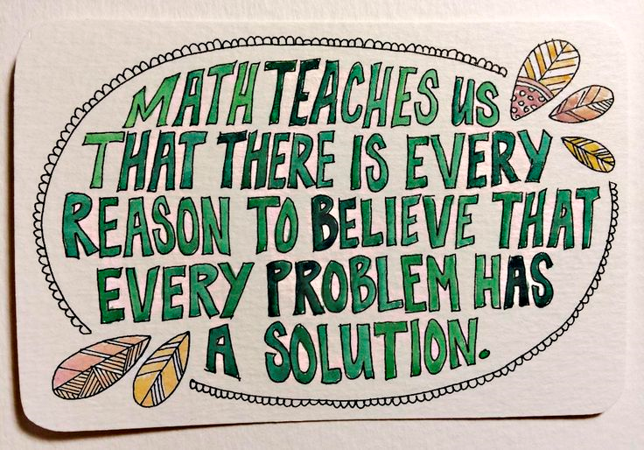

Math is everywhere.

From the patterns on a shell to the spiral arm of a galaxy, math is everywhere. No other subject in school gives students so much insight into the inner-workings of their universe. Every branch of science is just set dressing for the analysis of numbers, probability, and geometry. I want to teach a class that recognizes this awesome truth every day. If my students aren’t gasping with astonishment, than I’m not doing my job correctly.

A confident understanding of mathematics opens doors for students that they will benefit from for the rest of their life. Technology is the future, and employers are eager to hire the next generation of computer scientists and engineers. Low-skilled manufacturing jobs are a thing of the past. Today’s factory operator programs powerful and precise machinery, and the job requires an associate’s degree.

Kenai Public Borough School District (KPBSD) is adapting to the changing times. KPBSD has identified a commonality among successful school districts nation-wide: that 8th-graders are prepared to pass Algebra 1. This finding resulted in a system-wide goal to compact and speed the pace of learning in elementary school. Educators cannot excuse students who claim not to be “math people.” Teachers must rise to the challenge of teaching math to every student in their classroom.

I want my classroom to be… like a bubbling pot of water.

My classroom is a place that will be more interesting than after-school games and videos. The front of the class will be lit up with Parcan and Source 4 stage lights that I buy second hand from a local theatre. 50 watt speakers will blare whatever music or podcast can best enhance the day’s learning. Work tables and maker stations will be stocked with whatever kids need to create their dreams. I will diligently work to be more responsive than an iPad game.

Feedback is critical to maintain momentum in a classroom. I value relationships, and I strive to make my comments affirming and clear. Students can trust that I will never insult or belittle them in front of their peers. I will back up my verbal comments with a positive behavior intervention system (PBIS). I’ve been practicing these system for two years, and I’m so pleased to have found a classroom management system that matches my values.

I want my classroom to be an energetic atmosphere, like a bubbling pot of water. Periodically I will call the class together to witness a presentation. When the stage lights come up and the audience hushes down, students will teach students the important skills of the day. Or they will show off their new invention. I want to give students the respect and the power to command the classroom.

Interactive lessons and personalized projects will put students “on the hook” for their learning. So does my teaching style. I work hard at maintaining relationships with my students. When I challenge a student to try harder and dig deeper, they know it is because I believe in them. I expect effort and will reward it with truly awesome enrichment opportunities.

I believe in learning by doing.

A strong digital literacy program will be running concurrently with my math lessons. My students will light up during lessons about programming, web site design, and animation. I want to validate their hard work to learn the funny language of numbers. Project-based learning is a natural way to manage these endeavors.

I believe in learning by doing. I am an advocate for 1:1 computing, and will write grants to get a Raspberry Pi personal computer kit for every student in my class. Exciting projects await the students who will explore their device’s capabilities. From weather stations to retro video game emulators, the Raspberry Pi is an effective platform with substantial support for classroom integration. I aim to bring a 3D printer into the classroom too, to inspire and encourage my students to design.

Role modeling is my favorite way to teach. By engineering an activity where the teacher can learn alongside the students, I can make use of Vygotsky’s zone of proximal development. Individualized instruction is possible when I can sit side-by-side a student while we attempt to solve a problem. The benefits of a “Sage on the Stage” direct instruction model are compelling, however my personal style pushes me toward progressive models like cooperative learning.